Community ambassador newsletter October 2016

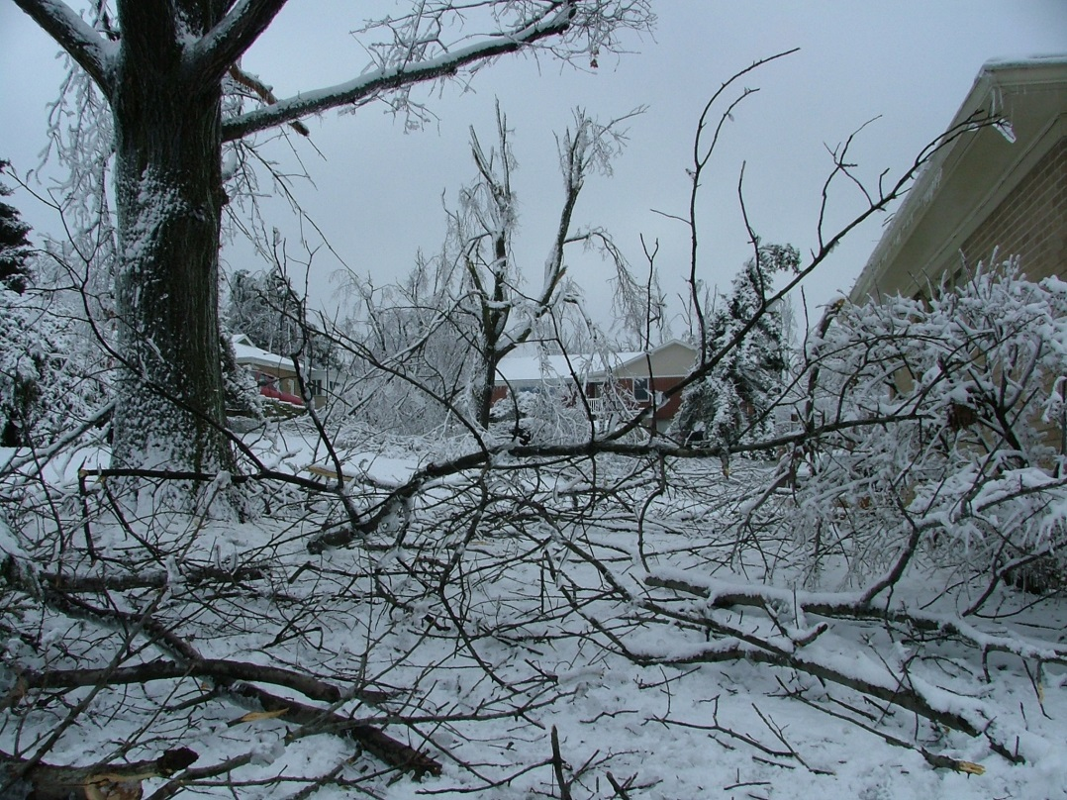

Preparing for Winter Storms and Saving on Your Holiday Energy Costs

Winter can be a festive time of year, but winter storms can also bring the most damaging winter weather - freezing rain and high winds. Winter storms often cause power outages by bringing down trees and tree limbs onto power lines. Ice storms can also damage power lines and cause outages.

Dayton Power and Light has several precautions to keep your family safe when the forecast calls for winter storms or damaging winter weather.

Before the weather gets bad, check the trees on your property to see if there are dying limbs or diseased trees that could cause problems this winter. DP&L trims trees and vegetation away from power lines and electric equipment in the right-of-way; however, customers are responsible for the lines that run from the pole to the home. To ensure trimming of the lines from the pole to the home is done safely, DP&L will temporarily shut power off to this service line in advance of trimming. For this free service, call DP&L at 937-331-4860 a few days in advance of the work to schedule an appointment.

If you have changed your phone number recently, or if you have changed to a cell phone only, please alert DP&L to your current telephone number by calling 800-433-8500 for residential customers and 800-253-5801 for business customers.

Prepare a storm kit (www.dpandl.com/outagetips) with an emergency radio (battery powered or wind-up), water, non-perishable food, flashlights and a first-aid kit. Your kit should also include daily medicine your family needs. Plan where you will go during an extended power outage, especially if someone in your family requires electricity for medical equipment. Although DP&L cannot guarantee priority restoration, it is helpful to alert DP&L about needed medical equipment at your location.

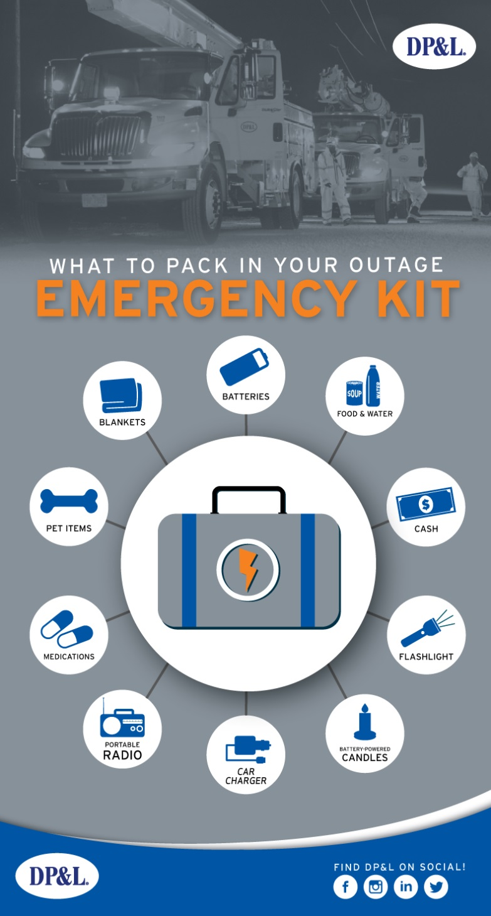

If a winter storm causes an outage, think safety first. Report your outage online (www.dpandl.com/outage) or call 877-OUTAGE (877-468-8243) and be sure to give DP&L the best phone number to reach you immediately.
Assume any downed lines are live and keep children and pets away. If you use a generator, read all instructions carefully before using. Use generators outdoors and well away from your home and windows where fumes could enter.

Turn off any heat-producing appliances, in case you are not home when the power is restored. Don’t place anything on top of those appliances to avoid starting a fire.

Trying to help a neighbor without power by running an electrical cord to their house is dangerous. It exposes the cords to damage from people walking or driving vehicles over them and damage caused by weather.

Save on holiday energy costs by gradually switching to LED electric lighting decorations, which can use 90% less energy and generate less heat for safety.

Always use electrical decorations designated for indoor or outdoor use and tested by recognized testing laboratories. Check all cords for fraying or damage before using and discard any damaged decorations.

When hanging lights or decorations outside, avoid contact with water, use a non-metal ladder and keep at least 10 feet from power lines.

Don’t overload your circuits or plug extension cords into each other. Only use holiday lights when you are awake and home. Use a timer for lights to avoid forgetting to turn them off overnight.

If you are upgrading your appliances this holiday season, let DP&L recycle your old working refrigerator and save you up to $150 in energy costs every year.

DP&L will even pay you a rebate of $50 for each unit or a rebate of $20 for each room air conditioner or dehumidifier picked up along with a fridge or freezer. Nearly 100% of the components will be reused or recycled. Just schedule a free, convenient pick-up time at www.dpandl.com/recycle or call 877-889-4765.

